**Bird Ringing Surveys**

**Hogacre Common: November & December 2020**

Between the 10th November and 15th December 2020, six bird ringing sessions were run at Hogacre Common. Just over 100 birds were processed from ten different species (Table 1, Fig.1). Since these were the first bird ringing surveys at Hogacre, most individuals caught were ‘new’ birds that had not previously been ringed (85%); while 15% of birds were retrapped in a subsequent session. Over 25 species were observed on site during the surveys, with two Lesser Redpoll being a particularly pleasing sighting in mid-November.

**Table 1** Number of new and retrapped individuals of each species caught between the 10th November and 15th December 2020.

|  |  |  |  |
| --- | --- | --- | --- |
| **Species** | **New** | **Retrap** | **TOTAL** |
| Blackbird | 1 | 0 | 1 |
| Blue Tit | 27 | 5 | 32 |
| Dunnock | 1 | 0 | 1 |
| Goldcrest | 4 | 1 | 5 |
| Goldfinch | 8 | 0 | 8 |
| Great Tit | 18 | 7 | 25 |
| Long-tailed Tit | 17 | 2 | 19 |
| Redwing | 7 | 0 | 7 |
| Robin | 3 | 1 | 4 |
| Wren | 2 | 0 | 2 |
| **TOTAL** | 88 | 16 | **104** |

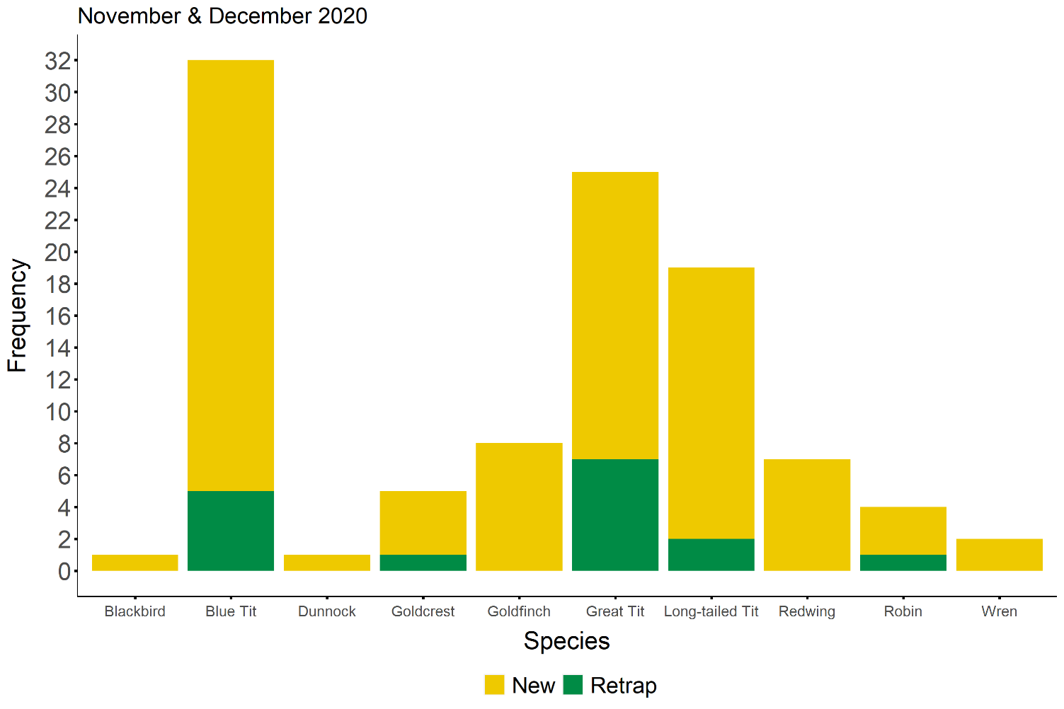

**Figure 1** Number of new and retrapped individuals of each species caught from 10th November - 15th December 2020.

**Bird Species**

**Hogacre Common: November - December 2020**

The following list is of bird species seen/heard at Hogacre Common from November – December 2020. It does not include birds flying over that were not using the site.

Mallard

Moorhen

Pheasant

Wood Pigeon

Collared Dove

Buzzard

Red Kite

Sparrowhawk

Kestrel

Green Woodpecker

Great Spotted Woodpecker

Dunnock

Wren

Blackbird

Song Thrush

Redwing

Fieldfare

Robin

Goldcrest

Chiffchaff

Blue Tit

Great Tit

Long-tailed Tit

Nuthatch

Magpie

Carrion Crow

Goldfinch

Chaffinch

Lesser Redpoll